

2025/26 Safeguarding for Parents: Information Booklet
North View Academy recognises our moral and statutory responsibility to safeguard and promote the welfare of pupils.
We will endeavour to provide a safe and welcoming environment where children are respected and valued. We will be alert to the signs of abuse and neglect and will follow our procedures to ensure that children receive effective support, protection and justice.
We have put together this booklet to give you some information about how we meet our safeguarding and child protection responsibilities. We have also included some tips to help you to keep your child safe.
Head Teacher: Miss L. Winship
Designated Safeguarding officers:
Miss L. Winship, Mr D. Moreno, Mrs K White and Mrs K Sanderson
Telephone: 0191 7070122
Email: northview@wiseacademies.co.uk

IF YOU ARE CONCERNED ABOUT THE SAFETY OR WELFARE OF YOUR CHILD, OR A CHILD YOU KNOW, YOU SHOULD
ACT WITHOUT DELAY.
YOU CAN ASK FOR ADVICE OR REPORT YOUR CONCERN TO:

Sunderland Safeguarding Children Board
Telephone: 0191 520 5560

Out of Hours Emergency Duty Team
Telephone: 0191 520 5552

Police
Telephone: 101

NSPCC Child Protection Helpline
Telephone: 0808 800 5000

Many people worry that their suspicions might be wrong, or that they will be interfering unnecessarily. If you wish, you can telephone for advice without identifying the child. If the conversation confirms that you are right to be concerned you can then give the child’s details. You will be asked for your name and address too, but the agencies will take anonymous calls, so if you really do not want to say who you are, you do not have to.
Remember, it is always better to be safe than sorry.

North View Academy looks after our pupils in the following ways:
- appointing a designated person who has additional training in child protection
- training all staff to recognise and respond to child welfare concerns
- having an up to date child protection policy
- having other safeguarding policies, such as anti-bullying and Online Safety
- adhering to health and safety regulations
- checking the suitability of all our staff to work with children
- sharing information with appropriate agencies if we have concerns
- working in partnership with parents and carers
- managing and supporting our staff team
- teaching our children what is right/wrong; appropriate and inappropriate
- teaching our children how to recognise risk and to make safe choices
- encouraging pupils to tell us if something is wrong
Internet and Mobile Device Safety
Mobile devices and computers are a part of everyday life for many children and young people. Used correctly, they are an exciting source of communication, fun and educational but used incorrectly or in the wrong hands they can be threatening and dangerous.
The risks include:
- Cyber-bullying, where hurtful messages or emails are sent to children
- Children accidentally or deliberately accessing violent or sexual explicit websites
- People talking to children and enticing them to engage in sexual conversations, photographs, video or actual meetings.
It is not practical to simply ban your child from using mobile devices and computers as they may well try to find a way to use them without your knowledge. They also need to learn how to manage the risks. Younger children are easier to supervise and you will decide if and when they should begin to use these technologies.
Tips to help manage the risks:
- Try to put the computer in a family room where it is easier for you to supervise your child’s online activity.
- Investigate whether the ‘parental controls’ available from your internet service provider will be helpful.
- Consider installing software that can filter inappropriate content.
- Talk to your child about their internet use. Ask them which sites they enjoy and why. Show you are interested, while understanding their need for some privacy.
- Ensure that your child knows they should never give their name and contact details to people they chat to on the internet. Remind them regularly.
- Gently explain that some people they talk to on the internet may not be who they say they are and might say or do unpleasant or hurtful things.
- Make it very clear that your child must never arrange to meet someone they have chatted to online without your permission. Their ‘new friend’ might well be a local young person of similar age, but they might not.
- Impress on your child that they can talk to you if they are worried about something that has happened during their internet use.

You may be alerted to question your child’s online activity if they are:
- Spending more and more time on the internet
- Being secretive – reluctant to talk about their internet activity, closing the screen page when you are close by.
- Spending less time with the family, or giving up precious hobbies and interests
- Losing interest in their schoolwork, regularly failing to complete homework
- Starting to talk about ‘new friends’ that you have not met and who do not visit your home
- Overly possessive of their mobile device or computer – perhaps overreacting if someone picks it up or asks to borrow it
- Showing fear of discomfort when their phone rings, or quickly turning it off without answering
- Undergoing a change in personality that you cannot attribute to any obvious cause.
Remember that none of these signs prove that your child is at risk in any way, but if you notice anything that confuses or worries you try talking things over with them. They may well tell you to stop fussing. They may be laid back. In any case, think about their demeanour and attitude as well as what they say. If you are still concerned contact one of the following helping agencies listed below or at the end of this booklet.

For further advice and information visit:
If you would like further support and guidance to help keep your child safe online, please contact one of our
CEOPS AMBASSADOR – Rachael Lax - 0191 7070122
SENDCo - Mr D Moreno - 01917070122
Alternatively you can visit the following websites:
Internet Watch foundation: www.iwf.org.uk
Child Exploitation and Online Protection Centre: www.ceop.gov.uk
Stop It Now! www.stopitnow.org.uk

We also have some information on the school website within the E Safety section
northview.wiseacademies.co.uk

Ten tips for keeping your temper
Children and young people can be infuriating sometimes. They need to be taught the right way to behave and sometimes they test parents to the limit. The trouble is we can lose our temper. As a consequence they may become frightened – or they may realise they have discovered just how to wind us up. If you feel you are losing your temper or are about to shout or lash out, try these tips to calm down. They may defuse the situation and give you time to consider how best to handle it:
- take some deep breaths
- count to 10
- close your eyes for a moment, to decide what to say
- depending on the age of your child, tell them calmly but firmly to go to their room
- depending on the age of your child, leave the room and get some fresh air
- turn on some music – nothing too loud
- sit down
- hug a pillow
- if another adult is present, hand over to them
- phone a friend
We are here to help
If you have concerns regarding how to manage your child’s behaviour or are worried about keeping your temper
Please talk to us.

Child abuse and what to look for
No parent wants to think about the possibility of their child becoming a victim of abuse, and most children are never abused. Even so, it is important for parents to be aware of the possibility and to know that help is available if the unthinkable does happen.
Although there is always a lot of media focus on ‘stranger danger’, the abduction of children is rare and threat from strangers is quite small. You should still ensure that your child knows the rules about keeping safe when they are out alone.
Most children know their abusers. They may be family members or friends of the family, someone who works with the child or someone who lives in the community.
There are four types of abuse: physical, emotional and sexual abuse, and neglect.
There are many signs, or indicators that a child might be suffering abuse. There may be injuries, but it is more likely that you will notice some change in your child’s behaviour. If you notice anything that concerns you, talk to your child to see if you can find out what is happening. Remember that, if your child is being harmed, he or she may be too frightened to tell you. If your child becomes distressed or you are not happy with the explanations, you could talk to an adult you trust or call a helpline or children’s social care services. Our designated person at the school will also try to help.
Some signs to look for are:
- bruises or other injuries
- pain or discomfort
- a change in behaviour – from quiet to loud, or from happy-go-lucky to withdrawn
- fear of a particular person, or reluctance to be alone with them
- secrecy around a relationship with a particular person
- reluctance to discuss where they go, or who they are with
- sexual talk or knowledge beyond their years
- being watchful, or always on edge
- losing interest in their appearance, hobbies or family life
- having money and refusing to say where it has come from
- wetting the bed
- becoming clingy
You will find more useful information in the school’s child protection policy (available on the school website).
Contact details of people who may offer support are on the ‘Sources of Support’ page of this booklet.

If your child is being bullied
Bullying – A definition
Bullying is defined as behaviour by an individual or a group, usually repeated over time, which intentionally hurts another individual, whether physically or emotionally.
Bullying includes: name calling, taunting, mocking, making offensive comments, kicking, hitting, and taking belongings, inappropriate messages, sending or posting inappropriate images by phone or via the internet, producing offensive graffiti, gossiping, excluding people from groups and spreading hurtful or untruthful rumours.
Children may try to hide the fact that they are being bullied because they are afraid or ashamed but you might notice some signs, for example your child might:
- Change their behaviour
- Come home with torn clothing
- ‘Lose’ their dinner money, or ask for extra money
- Complain regularly of headaches or stomach aches
- Have unexplained cuts and bruises
- Play truant
- Try to avoid going to school
We have an anti-bullying policy that may help us to identify and deal with any case of bullying in school, but bullying does not only take place in school, it can also happen in the home or in the community.
Bullying can be serious and cause a lot of distress. If your child tells you that they are being bullied in school, ask for their permission for you to tell us. They may not have told us themselves because they are afraid that the bully will find out and the bullying will get worse. Try to help them to understand that the bullying will not stop while it is kept secret. As soon as we know it is happening we will follow our anti-bullying procedures to try to stop it. It is also distressing to suspect that your child might be bullying other children. Our anti-bullying procedures include trying to support children who bully to change their behaviour, so please talk to us if you think your child needs some help. You will find some useful sources of information and support at the end of this booklet.
We are here to help
If you are worried your child is being bullied or bullying others - PLEASE tell us.

Social Media Age Restrictions
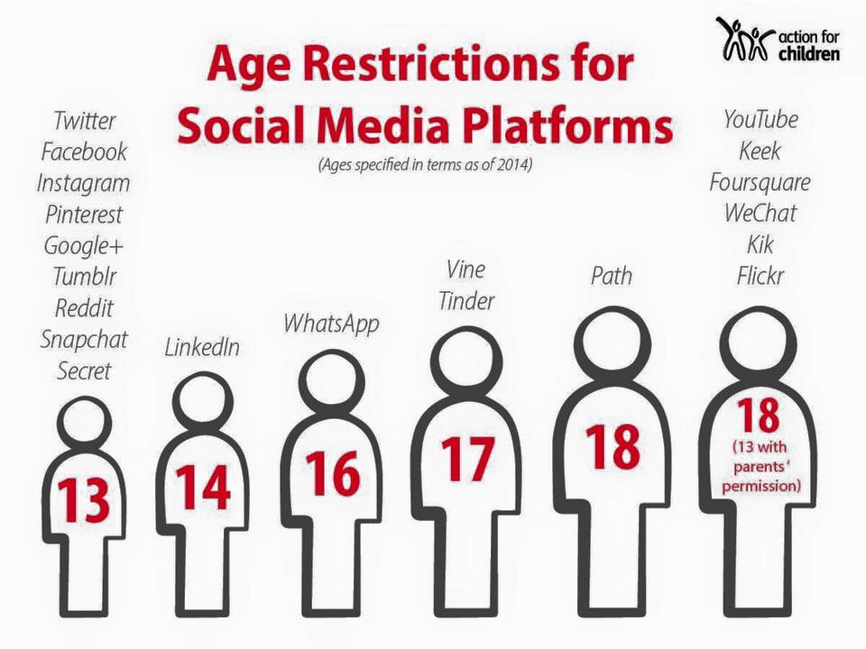

Prevent Duty
From July 2015 all schools (as well as other organisations) have a duty to safeguard children from radicalisation and extremism.
This means we have a responsibility to protect children from extremist and violent views in the same way we protect them from drugs or gang violence.
Importantly, we can provide a safe place for pupils to discuss these issues so they better understand how to protect themselves.
What does this mean in practice?
Many of the things we already do in school to help children become positive, happy members of society also contribute to the Prevent Strategy.
These include:
- exploring other cultures and religions and promoting diversity
- challenging prejudices and racist comments
- developing critical thinking skills and a strong, positive self-identity
- promoting the spiritual, moral, social and cultural development of pupils, as well as British values such as democracy
We will also protect children from the risk of radicalisation; for example, buy using filters on the internet to make sure they can’t access extremist and terrorist material and by vetting visitors who come into school to work with pupils.
Different schools will carry out the Prevent Duty in different ways, depending on the age of the children and the needs of the community.
We are here to help
If you would like any further information about the Prevent Duty and how we protect our children from Radicalisation,
Please contact the school.
Operation Encompass
Operation Encompass is a process by which key adults in our school are informed that a child attending their premises may have been affected by domestic abuse. This will usually mean that a child has been in the household where an incident of domestic abuse has taken place or has been exposed to domestic abuse.
We are here to help
If you would like any further information about Operation Encompass, our safeguarding and child protection procedures or would like to discuss any individual concerns, please contact:
Head Teacher: Miss L. Winship
Safeguarding Designated Leads: Miss L. Winship, Mr D. Moreno, Mrs K White and Mrs K Sanderson

What we will do if we have a concern about your child
If we are concerned that your child may be at risk of abuse or neglect we must follow the procedures in our child protection policy. You can look at the policy in school, on the website or receive a copy to take home. Please ask at reception.
The procedures have been written to protect all pupils. They comply with our statutory responsibilities and are designed to support pupils, families and staff. The procedures are based on the principle that the welfare of the child is the most important consideration.
In almost all circumstances we will talk to you about our concerns and will also tell you if we feel we must refer our concerns to children’s social care. We will ask your consent to make a referral but in some circumstances we may need to make the referral against your wishes. We will only do this if we genuinely believe that this is the best way to protect your child. The fact that you did not consent to the referral will be recorded.
If we think that talking to you first might in some way increase the risk to your child, we will report our concerns to children’s social care and take advice from them. We will normally tell you that the referral is being made so we will record the reasons why we decided to follow this course of action.
All child protection records are kept separate from your child’s general school file. Records are stored in a locked cabinet and drawer, and if stored on computer they are password-protected. The only members of staff that have access to the records are those who need to know about the concerns in order to protect and support your child. You can ask to see what information is held on your child and we will normally agree to this, but if we are unsure we will seek advice from the local authority designated officer (LADO) or children’s social care first.
Child protection is a very sensitive issue and it raises many questions and a range of strong emotions. We will do everything we can to support our pupils and you can be assured that any action we take will be in the best interests of your child.
We are here to help
If you would like any further information about our safeguarding and child protection procedures or
would like to discuss any individual concerns, please contact:
Head Teacher: Miss L. Winship
Safeguarding Designated Leads: Miss L. Winship, Mrs K White, Mr D. Moreno and Mrs K Sanderson

Complaints Procedure
There may be an occasion when you need to tell us that something has gone wrong. If you have a serious concern about the safety or welfare of your child or another pupil it may be dealt with under our child protection procedures. All other complaints, including those that may point to poor practice by a member of staff, will be dealt with firstly through the complaints procedure. A full copy of our complaints policy and procedure is available from reception or can be downloaded from our website northview.wiseacademies.co.uk

Sources of Support and Information
Child Protection – National
NSPCC helpline: 0808 800 5000
ChildLine: 0800 1111
Child Law Advice Line: 08088 020 008
Africans Unite Against Child Abuse: 0844 660 8607
Bullying – National
NSPCC helpline: 0808 800 5000
ChildLine: 0800 1111
Kidscape: 08451 205 204
Mental Health – National
Young Minds: 0808 802 5544
Mental Health Foundation: 020 7803 1100
Mind: 0845 766 0163
Parent Support – National
Parent Line Plus: 0808 800 2222
Sexual Harm and Sexually Harmful Behaviour – National
Stop It Now: 0808 1000 900
The AIM project: www.aimproject.org.uk
Internet Safety – National
ChildNet International: www.childnet.com
Child Exploitation and Online Protection: www.ceop.gov.uk 0870 000 3344
Internet Watch Foundation: www.iwf.org.uk
Think U Know: www.thinkuknow.org.uk 0870 000 3344
Local Agencies
Sunderland Safeguarding Children Board
Telephone: 0191 520 5560
Out of Hours Emergency Duty Team
Telephone: 0191 520 5552
Police
Telephone:101

