Pupil premium strategy statement – North View Academy

This statement details our school’s use of pupil premium funding to help improve the attainment of our disadvantaged pupils.
It outlines our pupil premium strategy, how we intend to spend the funding in this academic year and the outcomes for disadvantaged pupils last academic year.

School overview
Detail | Data
Number of pupils in school | 69 (Dec 2025)
Proportion (%) of pupil premium eligible pupils | 46.4%
Academic year/years that our current pupil premium strategy plan covers (3-year plans are recommended – you must still publish an updated statement each academic year) | 2025 – 2026  2026 – 2027  2027 – 2028
Date this statement was published | December 2025
Date on which it will be reviewed | Termly
Statement authorised by | LGB
Pupil premium lead | Lisa Winship
Governor / Trustee lead | Christine Collins

Funding overview
Detail | Amount
Pupil premium funding allocation this academic year | £70005
Pupil premium funding carried forward from previous years | £0
Total budget for this academic year | £70005

Part A: Pupil premium strategy plan

Statement of intent
North View Academy is a primary specialist provision for pupils with Social, Emotional and Mental Health (SEMH) needs and Autistic Spectrum Disorder (ASD). Many of our pupils face significant barriers to learning which include social, communication and interaction difficulties, emotional regulation needs, sensory differences, anxiety, disrupted early experiences, trauma and gaps in prior learning. All of our pupils have Education, Health and Care Plans (EHCPs) and a high number of children known to social care. 46.4% of our pupils are eligible for Pupil Premium funding.
This statement outlines how Pupil Premium funding is used to raise attainment, improve social, emotional, communication and interaction outcomes, and support pupils to achieve the outcomes identified in their EHCPs.
At North View Academy we focus on supporting pupils to achieve high levels of engagement in learning so that all pupils attend, enjoy school and achieve in every aspect of school life. We also aim to ensure that all disadvantaged children have the same opportunities, experiences, and access to a high-quality education and that barriers are removed.
High-quality teaching and learning are at the heart of this policy and school approach, focusing on areas where disadvantaged children require the most support, grounded in the latest educational research and evidence-based practices. This approach has proven to be the most effective in narrowing the outcomes gap for disadvantaged children and improving overall school outcomes. We will regularly monitor and evaluate the impact of our approaches, adapting strategies to sustain and improve the outcomes of all pupils. The approaches we use carefully assess and respond to the individual needs of children at North View Academy, ensuring that support is personalised and effective. The key principles of this policy are:
• To ensure that all disadvantaged children at North View reach their potential
• To promote high levels of engagement in learning
• To develop the life chances of all disadvantaged children
• To enrich the lives of disadvantaged children by developing their cultural capital and
wider curriculum experiences.

Challenges
This details the key challenges to achievement that we have identified among our disadvantaged pupils.
Challenge number | Detail of challenge
1 | Pupils come to North View Academy having struggled to thrive in the mainstream setting and often have a negative outlook on education and engagement in their learning. For some pupils this also includes periods of non-school attendance / disrupted attendance prior to starting North View Academy.
2 | Due to difficulties outlined in Challenge 1 and / or due to additional learning needs pupils often arrive at North View Academy with significant gaps in their education and/ or delays in their core skills (reading, writing, maths) and working at significantly lower than the expected levels.
3 | Our pupils have a wide range of barriers to learning, including emotional dysregulation and heightened anxiety, which can impact engagement and readiness to learn. Low self-esteem and reduced confidence may affect their willingness to participate and take academic risks. Difficulties with communication and interaction can hinder the development of positive peer relationships and effective collaboration, while sensory processing differences may result in increased sensitivity to the learning environment, leading to distraction or distress. Together, these challenges can limit pupils’ ability to access the curriculum consistently and make sustained progress without targeted support.
4 | Some of our pupils experience inconsistent attendance linked to emotional wellbeing needs, including anxiety, emotional regulation difficulties and challenges with transitions. This can limit continuity of learning, impact progress, and reduce opportunities to develop positive relationships and routines.
5 | Many of our pupils have low resilience related to their SEN and find it difficult to manage change, transitions and sensory environments, which can lead to heightened anxiety, reduced engagement and barriers to learning.

Intended outcomes
This explains the outcomes we are aiming for by the end of our current strategy plan, and how we will measure whether they have been achieved.
Intended outcome | Success criteria
Through participation in Forest School sessions, pupils will develop improved emotional regulation and resilience, leading to increased engagement in learning. The outdoor, experiential approach will support pupils to build self-esteem and confidence, enabling them to feel more secure, motivated, and positive about their abilities both in and out of the classroom. | Pupils demonstrate improved emotional regulation, with a reduction in anxiety-related behaviours and emotional dysregulation during the school day.  Pupils show increased confidence and self-esteem, demonstrated through greater willingness to try new activities, take risks in learning, and express their ideas.  Improved social interaction and communication skills, with pupils able to work collaboratively, follow instructions, and build positive relationships with peers and adults.  Pupil voice and staff observations indicate improved wellbeing, enjoyment of learning, and a sense of achievement.
To improve whole school reading outcomes for pupils, showing good progress from starting points (on entry / start of school year depending on mobility). | A higher proportion of pupils reached required level in reading.
All pupils make improved progress in writing, with increased confidence, independence and attainment as a result of consistently embedded quality first teaching and the implementation of a new whole-school writing framework. | Quality first teaching in writing is consistently implemented across all classes, evidenced through learning walks, planning scrutiny and pupil work  Staff demonstrate secure understanding and use of the new writing framework  Pupils show improved engagement and stamina in writing tasks  A higher proportion of disadvantaged pupils meet writing targets  Writing outcomes show measurable improvement from individual starting points
To improve whole school maths outcomes for pupils, showing good progress from starting points (on entry / start of school year depending on mobility). | A higher proportion of pupils reached required level in maths.
LTP of enrichment (visits and visitors) which support the curriculum teaching. | A LTP of enrichment is in place to provide real life experiences for pupils learning
Attendance is improved for pupils with persistent absence. | Attendance figures are improved with procedures in place to tackle persistent absence.
Pupils show improved social, emotional and academic outcomes as a result of timely, targeted interventions delivered individually and in small groups, enabling them to better access learning and achieve their targets. | Targeted interventions are matched to pupils’ identified needs and EHCP outcomes  Pupils demonstrate improved emotional regulation, engagement and readiness to learn  Progress is evident in academic skills from individual starting points  Pupils are able to sustain learning for longer periods and participate more positively in group activities  A higher proportion of disadvantaged pupils meet their academic and social-emotional targets

Activity in this academic year
This details how we intend to spend our pupil premium funding this academic year to address the challenges listed above.

Teaching (for example, CPD, recruitment and retention)
Budgeted cost: £ 48,730
Activity | Evidence that supports this approach | Challenge number(s) addressed
Pupils participate in regular Forest School sessions in the school grounds, delivered by qualified Forest School staff. | Research indicates that Forest School approaches significantly enhance pupils’ emotional regulation and resilience, which in turn supports increased engagement in learning. By providing an outdoor, experiential environment, pupils have opportunities to develop self-esteem, confidence, and a sense of agency. This approach enables them to feel more secure, motivated, and positive about their abilities, both within the classroom and beyond, fostering social, emotional, and academic growth.  Forest Schools: Impact on Young Children in England and Wales (Forest Research / New Economics Foundation) – shows increased self-confidence, independence and motivation through Forest School participation. Forest Research  Forest School and Mental Wellbeing (Canterbury Christ Church University) – finds significant improvements in resilience and wellbeing following Forest School programmes. Canterbury Repository  Forest School Improves Mental Health and Well-Being (Children & Nature Network) – provides qualitative evidence of improved emotional regulation, confidence, resilience and social interactions among participants. Children & Nature Network | 1, 3, 5
Continue to update, resource and upskill staff in the chosen DfE accredited phonics scheme (Power Literacy / STEPS). | EEF - Phonics is an approach to teaching some aspects of literacy, by developing pupils’ knowledge and understanding of the relationship between written symbols and sounds. This involves the skills of hearing, identifying and using the patterns of sounds or phonemes to read written language. The aim is to systematically teach pupils the relationship between these sounds and the written spelling patterns, or graphemes, which represent them. Phonics emphasises the skills of decoding new words by sounding them out and combining or ​‘blending’ the sound-spelling patterns.  EEF Teaching and Learning Toolkit: Phonics - additional 5 months progress | 2
Deliver high quality CPD for staff in phonics, including those delivering targeted interventions |  | 2
Embed Reading comprehension through daily lessons (CPD) | EEF - The average impact of reading comprehension strategies is an additional six months’ progress over the course of a year. Successful reading comprehension approaches allow activities to be carefully tailored to pupils’ reading capabilities, and involve activities and texts that provide an effective, but not overwhelming, challenge.  EEF Teaching and Learning Toolkit: Reading Comprehension Strategies – additional 6 months progress | 2
Deliver high quality CPD in Reading linked Power Literacy scheme, with a focus on teaching and learning principles |  | 2
Deliver high quality CPD in Mathematics linked to rapid recall | EEF research highlights the importance of developing pupils’ fluency and rapid recall of number facts, as this reduces cognitive load and enables pupils to engage more effectively with higher-level mathematical reasoning and problem-solving. The EEF Improving Mathematics guidance emphasises that regular, structured practice in mental calculation and recall of basic facts (such as number bonds and multiplication tables) is a key component of effective maths teaching. EEF-funded evaluations of fluency-focused programmes show that approaches which strengthen mental calculation strategies and memory can lead to measurable improvements in maths attainment, with some studies indicating the equivalent of up to three months’ additional progress. These findings support the use of targeted, systematic recall practice as part of quality first teaching and intervention for disadvantaged pupils.  https://d2tic4wvo1iusb.cloudfront.net/eef-guidance-reports/early-maths/EEF_Maths_EY_KS1_Guidance_Report.pdf?v=1635355217 | 2
Purchase mathematics resources to support the learning and teaching within mathematics |  | 2

Targeted academic support (for example, tutoring, one-to-one support, structured interventions)
Budgeted cost: £13,400
Activity | Evidence that supports this approach | Challenge number(s) addressed
Deputy Head teacher and SENDCo to facilitate coaching and mentoring for staff and small group interventions for targeted groups. | Some pupils may require additional support alongside high-quality teaching in order to make good progress. The evidence indicates that small group and one-to-one interventions can be a powerful tool for supporting these pupils when they are used carefully.  Evidence shows that small group tuition is effective and, as a rule of thumb, the smaller the group the better. Some studies suggest that greater feedback from the teacher, more sustained the engagement in smaller groups, or work which is more closely matched to learners’ needs explains this impact.  https://educationendowmentfoundation.org.uk/support-for-schools/school-planning-support/2-targeted-academic-support?utm_source=chatgpt.com  https://educationendowmentfoundation.org.uk/education-evidence/teaching-learning-toolkit/small-group-tuition  https://educationendowmentfoundation.org.uk/education-evidence/teaching-learning-toolkit/teaching-assistant-interventions | 1,2,3,4,5
TA trained to deliver weekly Lego Therapy sessions | LEGO® Therapy is used widely in UK schools to develop social communication skills (e.g., sharing, turn-taking, problem-solving) in autistic pupils and those with social-emotional needs, and is recommended in SEMH intervention toolkits. National Autistic Society+1  Autism Alliance – Professional Practice guidance on using LEGO® Therapy: https://www.autism.org.uk/advice-and-guidance/professional-practice/lego-pilot | 1,2,3,4,5
 |  | 1,2,3,4,5

Wider strategies (for example, related to attendance, behaviour, wellbeing)
Budgeted cost: £7,875
Activity | Evidence that supports this approach | Challenge number(s) addressed
Structured program of rewards and celebrations to raise the profile of attendance. | DfE - Pupils with higher attainment at KS2 and KS4 had lower levels of absence over the key stage compared to those with lower attainment.  In 2024-25, pupils with an Education, Health and Care Plan (EHCP) had an overall absence rate of 13.7%, compared with 6.0% for pupils with no identified SEN. Persistent absence (missing 10%+ of sessions) was 36.9% for pupils with an EHCP versus 16.5% for pupils with no identified SEN. Explore Education Statistics  Centre for Young Lives highlights that persistent non-attendance is much higher among SEN pupils (e.g., ~37.6% for those with EHCPs vs ~18.6% without SEN). Centre for Young Lives  Analyses tracking absence data show children with certain types of SEN (e.g., profound and multiple learning difficulties or social, emotional and mental health needs) have especially high rates of persistent absence. The Centre for Social Justice | 1,4
A LTP of enrichment activities / visits in place to provide real life experiences for pupils learning and support the curriculum teaching and EHCP outcomes. | Embedding an enrichment curriculum to provide real life experiences for pupils’ learning that includes targeted visits, visitors and high-quality resources supports SEN pupils’ learning because it enhances engagement, motivation and real-world application of knowledge. Evidence shows that experiential learning and enrichment activities improve confidence, social interaction and behaviour for learning—especially for pupils with SEMH and ASD—by providing context-rich, multisensory experiences that deepen understanding and support access to the wider curriculum.  (Evidence from DfE/National Trust-Field Studies Council/ EEF) | 1,2,3,4,5

Total budgeted cost: £70,005

Part B: Review of the previous academic year

Outcomes for disadvantaged pupils
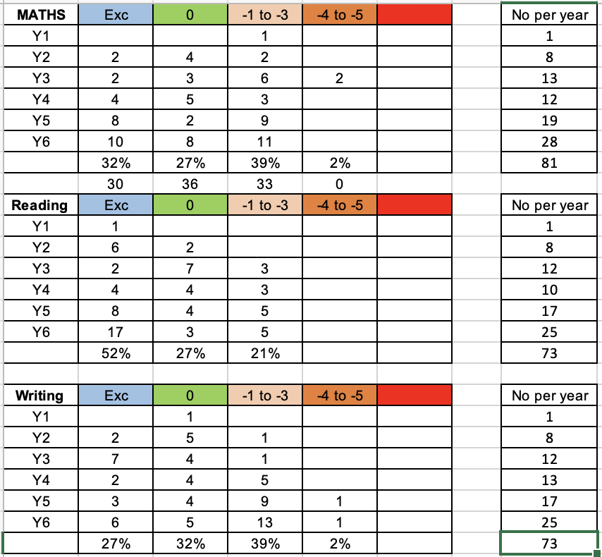

Attendance 2024 – 2025:

Whole school – 93.84%
PP pupils – 93.21%

Externally provided programmes
Programme | Provider
Power Literacy | McKie Mastery
White Rose Maths | White Rose Maths

Service pupil premium funding (optional)
For schools that receive this funding, you may wish to provide the following information: How our service pupil premium allocation was spent last academic year
The impact of that spending on service pupil premium eligible pupils

