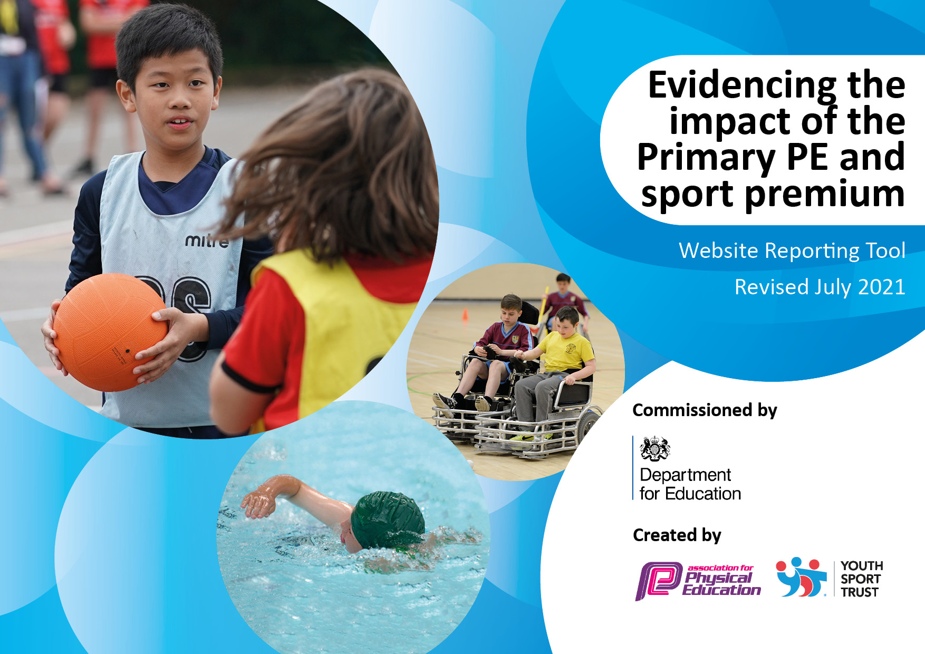
North View Academy 2022 - 2023
Projected Spend & Impact
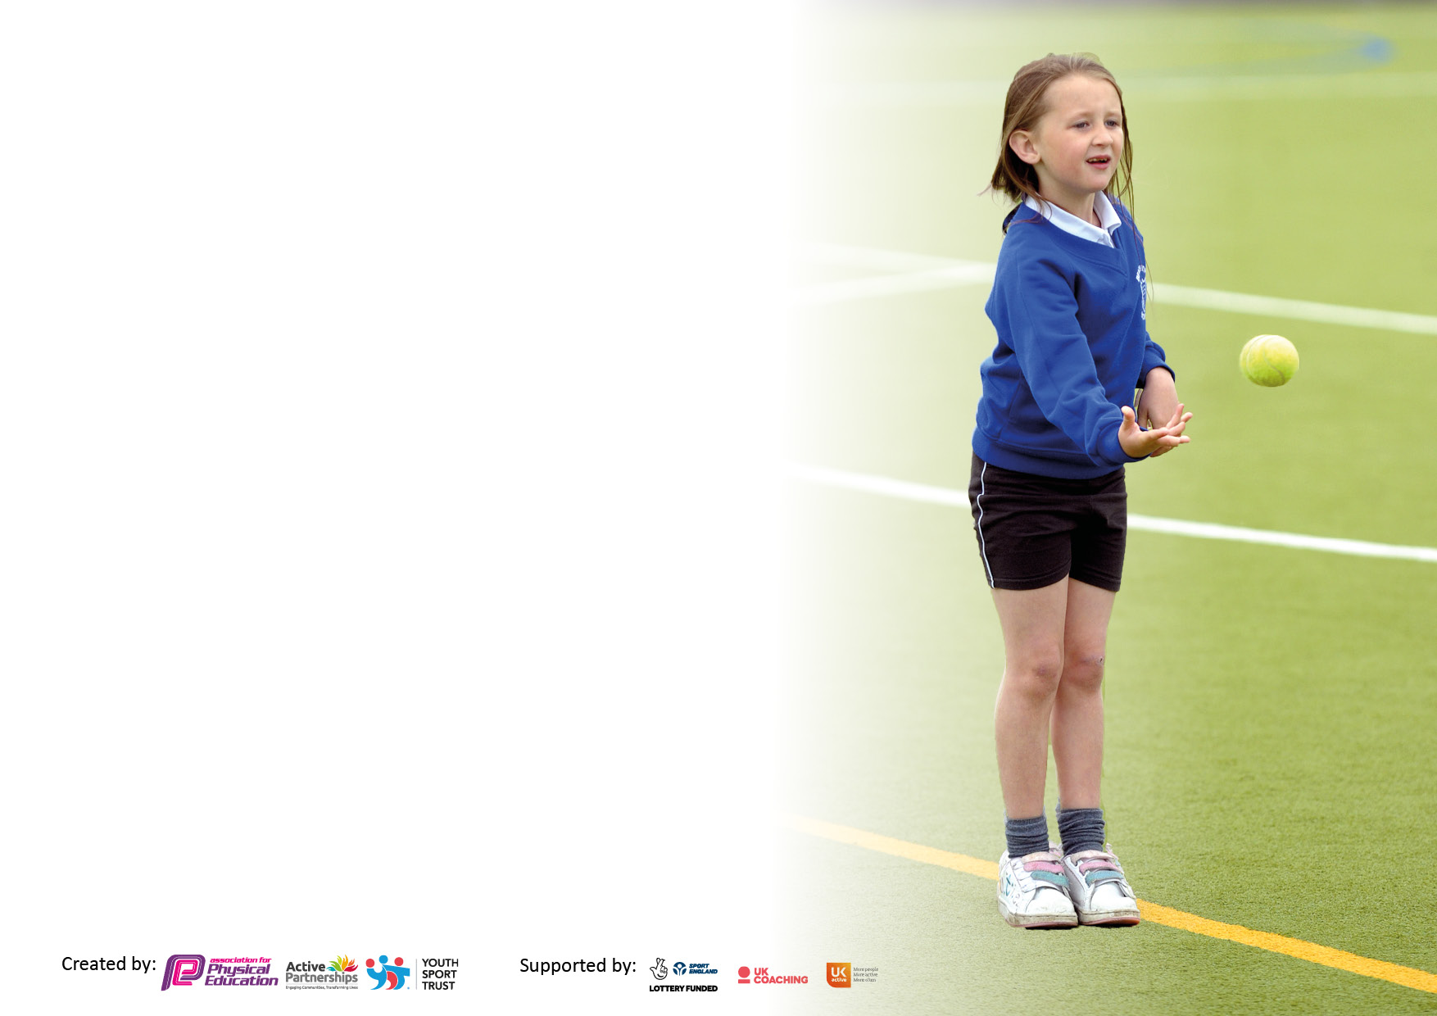

The Government is providing additional PE and sport funding to all primary schools. The aim of this funding is to improve the quality, provision and sustainability of PE and sport in our schools and develop healthier lifestyles for our pupils.

At North View Academy we use this funding to make additional and sustainable improvements to the quality of PE, school sports and physical activity (PESSPA) we offer.

This means we will use the premium to:
1. To develop or add to the PESSPA already in place in school
2. To develop resources, skills and opportunities to ensure that improvements made now will benefit pupils joining the school in future years.

The 5 key indicators where improvements should be seen are:
1. The engagement of all pupils in regular physical activity, aiming for 30 minutes a day within school time.
2. The profile of PE and sport is raised across the school as a tool for whole school improvement.
3. Increased confidence, knowledge and skills of all staff in teaching PE and sport.
4. Broader experience of a range of sports and activities offered to all pupils.
5. Increased participation in competitive sport.

Details with regard to funding
Please complete the table below.

Total amount carried over from 2021/22 | £0
Total amount of funding for 2022/23. To be spent and reported on by 31st July 2023. | £16,800
Swimming Data
Please report on your Swimming Data below.

Meeting national curriculum requirements for swimming and water safety.

Pupils do not start swimming lessons in NVA until Y4. Our current Y6 pupils have not been able to participate in swimming lessons at NVA due to COVID restrictions. Our swimming lesson provider no longer has availability for our school and we have been unable to secure another swimming slot in a suitable venue. We are awaiting a possible slot from a local school whose pool is currently undergoing refurbishment.
What percentage of your current Year 6 cohort swim competently, confidently and proficiently over a distance of at least 25 metres?  N.B. Even though your pupils may swim in another year please report on their attainment on leaving primary school at the end of the summer term 2022 | % No data currently available
What percentage of your current Year 6 cohort use a range of strokes effectively [for example, front crawl, backstroke and breaststroke]? | % No data currently available
What percentage of your current Year 6 cohort perform safe self-rescue in different water-based situations? | % No data currently available.
Schools can choose to use the Primary PE and sport premium to provide additional provision for swimming but this must be for activity over and above the national curriculum requirements. Have you used it in this way? | No

Action Plan and Budget Tracking
Capture your intended annual spend against the 5 key indicators. Clarify the success criteria and evidence of impact that you intend to measure to evaluate for pupils today and for the future.

Academic Year: 2022/23 | Total fund allocated: £16,800 | Date Updated: October 2022
Key indicator 1: The engagement of all pupils in regular physical activity – Chief Medical Officers guidelines recommend that primary school pupils undertake at least 30 minutes of physical activity a day in school |  |  |  | Percentage of total allocation:
 |  |  |  | 20.1%
Intent | Implementation |  | Impact
Focus | Actions | Funding allocated | Evidence | Sustainability and suggested next steps
Create more opportunities for children to sustain 30 minutes of physical activity every day.  Use Daily Mile as a tool to engage pupils in daily activity and link to our Moki step programme.  New outdoor sports equipment – climbing equipment. | Set up the Moki programme to enable all classes to use the Moki step counters purchased last year.  Develop use of ‘Active Classroom’ – pupils are encouraged to engage in short activity breaks regularly throughout the day.  Subscription to online activity Programme – Cybersmart (active classroom/wake and shake activities)  Pupils encouraged to access mile track regularly.  Teachers/TAs will encourage and support each child to use the outdoor equipment when exercising outside. | £180  £3,195 | Pupils encouraged and rewarded for keeping active throughout the day. Tracking of steps taken – individually and in classes.  Improved engagement in lessons and boosting physical health.  An innovative way for children to take part in regular daily activity. Children will be able to develop their balance and coordination whilst having fun with their friends. | Pupils engage in Moki daily steps activities  PE subject leader to ensure sporting/physical activity  opportunities are available and actively encouraged.  Varied activities/resources on offer at play times to encourage pupils to be active.  Daily exercise encouraged to improve physical health and well-being.  Children will use the outdoor equipment for regular exercise and to support and encourage other children (younger) to access the apparatus.
Key indicator 2: The profile of PESSPA being raised across the school as a tool for whole school improvement |  |  |  | Percentage of total allocation:
 |  |  |  | 41.7%
Intent | Implementation |  | Impact
Focus | Actions | Funding | Evidence | Sustainability and suggested next steps
Raise the profile of PE with parents and children, to encourage children to take part in school sports and parents to support them.  Improve indoor PE facilities to enable more pupils to access sports hall daily.  . | Share all sporting achievements in weekly assembly and on schools social media.  School Fun Day with various sporting activities to raise money for local charity. Event to be shared on social media.  School Sports Day – various sporting activities/events.  Pupils participate in competitions and festivals – inter and intra-school.  Install dividing sports hall curtain to allow 2 lessons to take place in hall at any one time – doubling timetable availability for PE lessons when outside facilities not available due to weather. | £1000  £6,000 | All participation and success shared with the rest of the school during assemblies.  Race for Life event and School Fun Day – updates of money raised and distance run to be recorded when completed.  Achievements recorded and rewarded. Pupils motivated to increase level of activity.  Pupils given the opportunity to attend festivals of sport to increase their enjoyment and opportunities.  PE hall divider installed and operational. | Sports noticeboard in main entrance to include team photos and successes from competitions.  Continue to increase participation in festivals.  More flexibility for PE timetable due to more availability of PE hall.

Key indicator 3: Increased confidence, knowledge and skills of all staff in teaching PE and sport |  |  |  | Percentage of total allocation:
 |  |  |  | 0%
Intent | Implementation |  | Impact
Focus | Actions | Funding | Evidence | Sustainability and suggested
 |  |  |  | next steps
New PE scheme of work operational across school  Develop knowledge, skills and confidence to teach the whole child through sport. | Roll out of new scheme shared with staff in Curriculum meetings. CPD offered via Get Set 4 PE  CPD in a range of activities also provided (online training) through our subscription. |  | A sense of fun and enjoyment through sport and PE is engendered in all pupils.  PE subject lead to share resources / online support with staff - curriculum meetings.  Staff develop confidence in delivering high quality PE lessons.  Pupils will be engaged and develop skills. | PE scheme is in place, including progression ladders, curriculum mapping and a wide range of teaching and learning resources. This will help develop staffs PE knowledge, understanding and confidence in teaching PE. Scheme also provides regular CPD.
Key indicator 4: Broader experience of a range of sports and activities offered to all pupils |  |  |  | Percentage of total allocation:
 |  |  |  | 35.2%
Intent | Implementation |  | Impact
Focus | Actions | Funding | Evidence | Sustainability and suggested next steps
To continue to enable pupils to experience a wide range of sports and activities.  To engage, motivate and enhance the learning of all pupils.  Offer extra-curricular sporting opportunities (Friday afternoons).  To encourage healthy lifestyles and offer pupils the opportunity to experience new activities in addition to those offered through the National Curriculum.  To ensure that staff and pupils have access to high quality PE equipment for use in lessons and during unstructured times. | Continue to offer a range of workshops and activities beyond those offered through NC PE sessions: including Boccia, New Age Kurling, Yoga, indoor archery, hula-hooping  Continue engagement with School Games and Panathlon initiatives.  Create links with local sports groups (eg. Foundation of Light).  Acquiring and upgrading appropriate school PE and sensory equipment | £1,200  £1,725  £3,000 | Pupils will have access to a broader range of sporting activities and will have the opportunity to experience sports/activities that would not ordinarily be offered via the PE curriculum.  Pupils will be engaged and nurture an enjoyment of physical activity.  Pupils and staff will have access to a wider range of good quality PE and sensory equipment to develop skills and enhance teaching and learning experiences. | With equipment purchased to support these extra-curricular activities, pupils will be able to participate and develop their skills well into the future. Staff will be able to offer follow-up sessions to encourage further activity and development of skills.  With the improvement of the range and quality of our PE and sensory resources staff will be able to deliver engaging and well-resourced lessons and activities well into the future.
Key indicator 5: Increased participation in competitive sport |  |  |  | Percentage of total allocation:
 |  |  |  | 3%
Intent | Implementation |  | Impact
Focus | Actions | Funding | Evidence | Sustainability and suggested next steps
To participate in competitive sports, eg. Sportability, Sportshall Athletics, Panathlon and various city wide/regional, sportsability festivals and competitions.  Sports kits purchased for competitions | Maintain links with School Games officer.  Engage in competitions and festivals.  Engage in School Games and Sunderland Active Schools Charter programmes.  Children and to be smart and well-presented when attending competitions/events to represent the school. | £500 | Pupils will have access to a broad range of sporting activities and will have the opportunity to participate in festivals and competitive sports.  Gold Standard Awards achieved in the Sunderland Schools Active Charter and Silver award in Schools Games Award Scheme.  Children are smart, well-presented and easily identifiable as a team/school | Links with organisations and sporting groups carried forward and pupils encouraged to continue participation and engagement in long-term physical activities.
TOTAL |  | £16,800

Signed off by
Head Teacher: | Mr G Mellefont
Date: | 5.10.22
Subject Leader: | Miss L Winship
Date: | 5.10.22
Governor:
Date:

