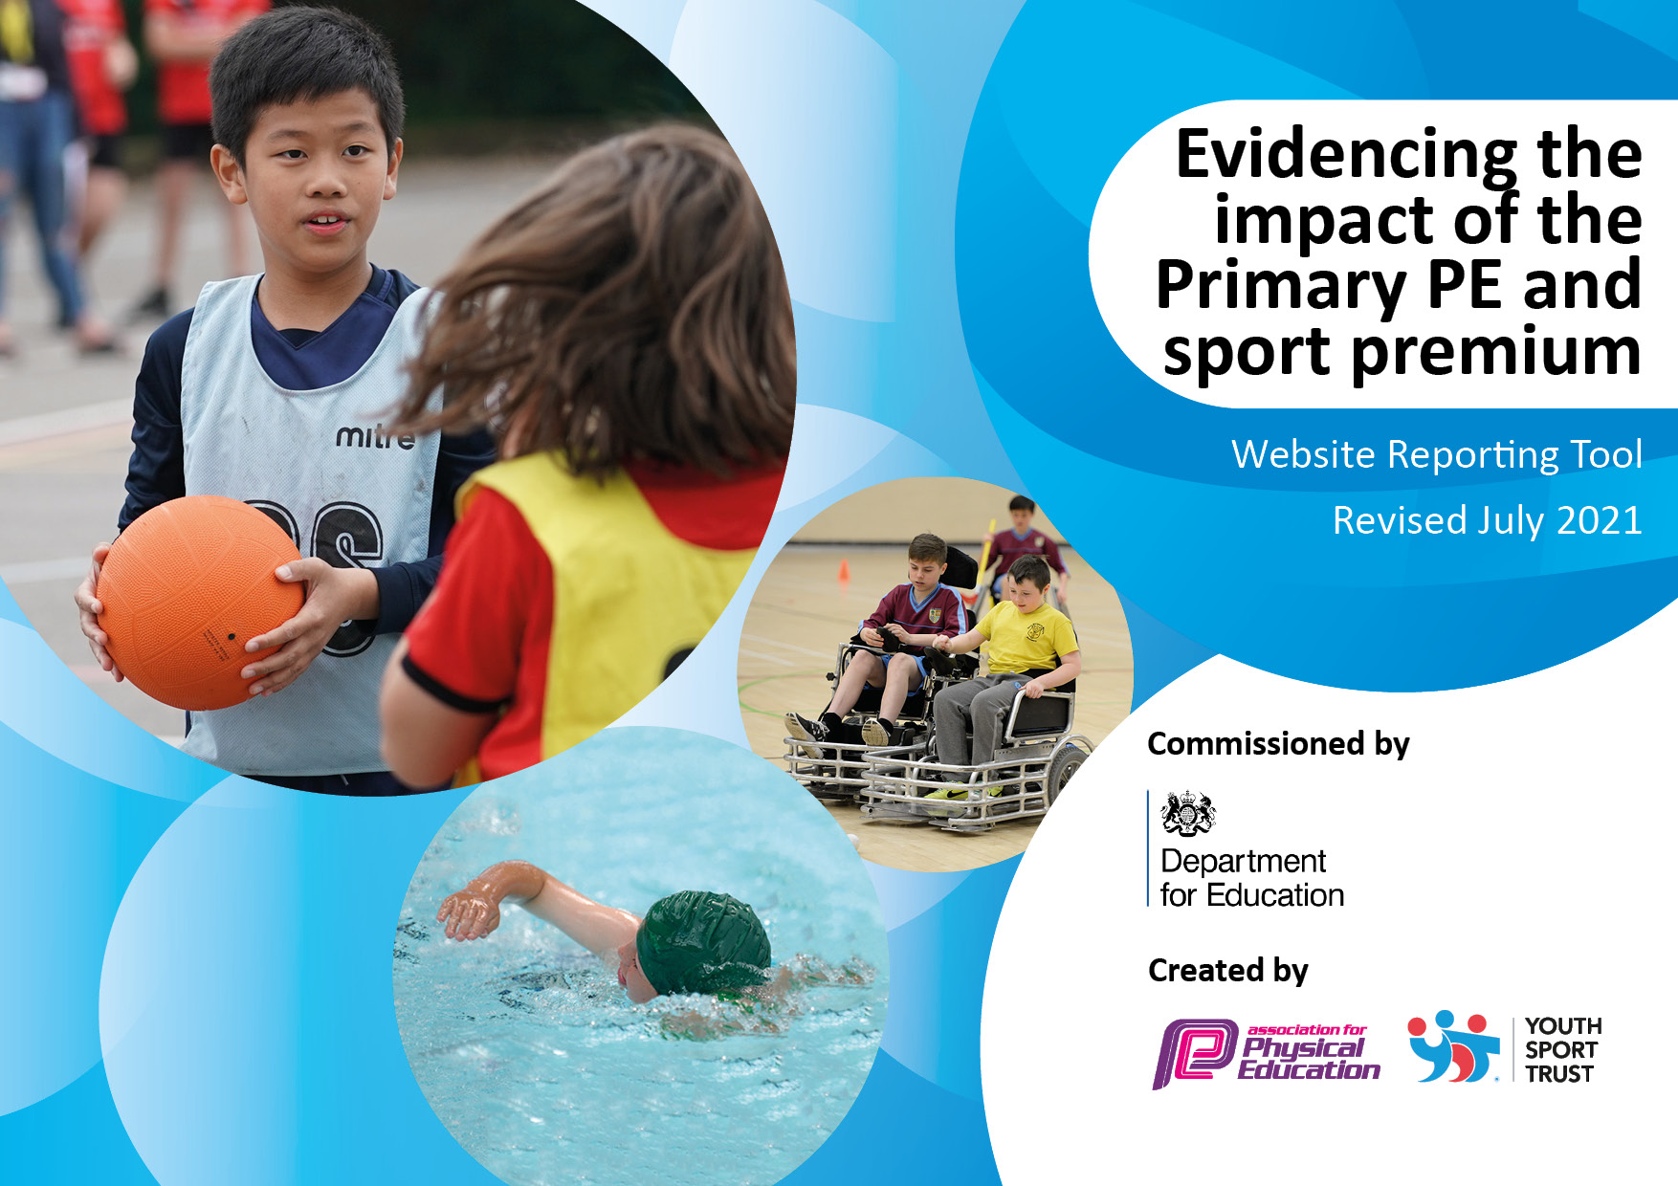
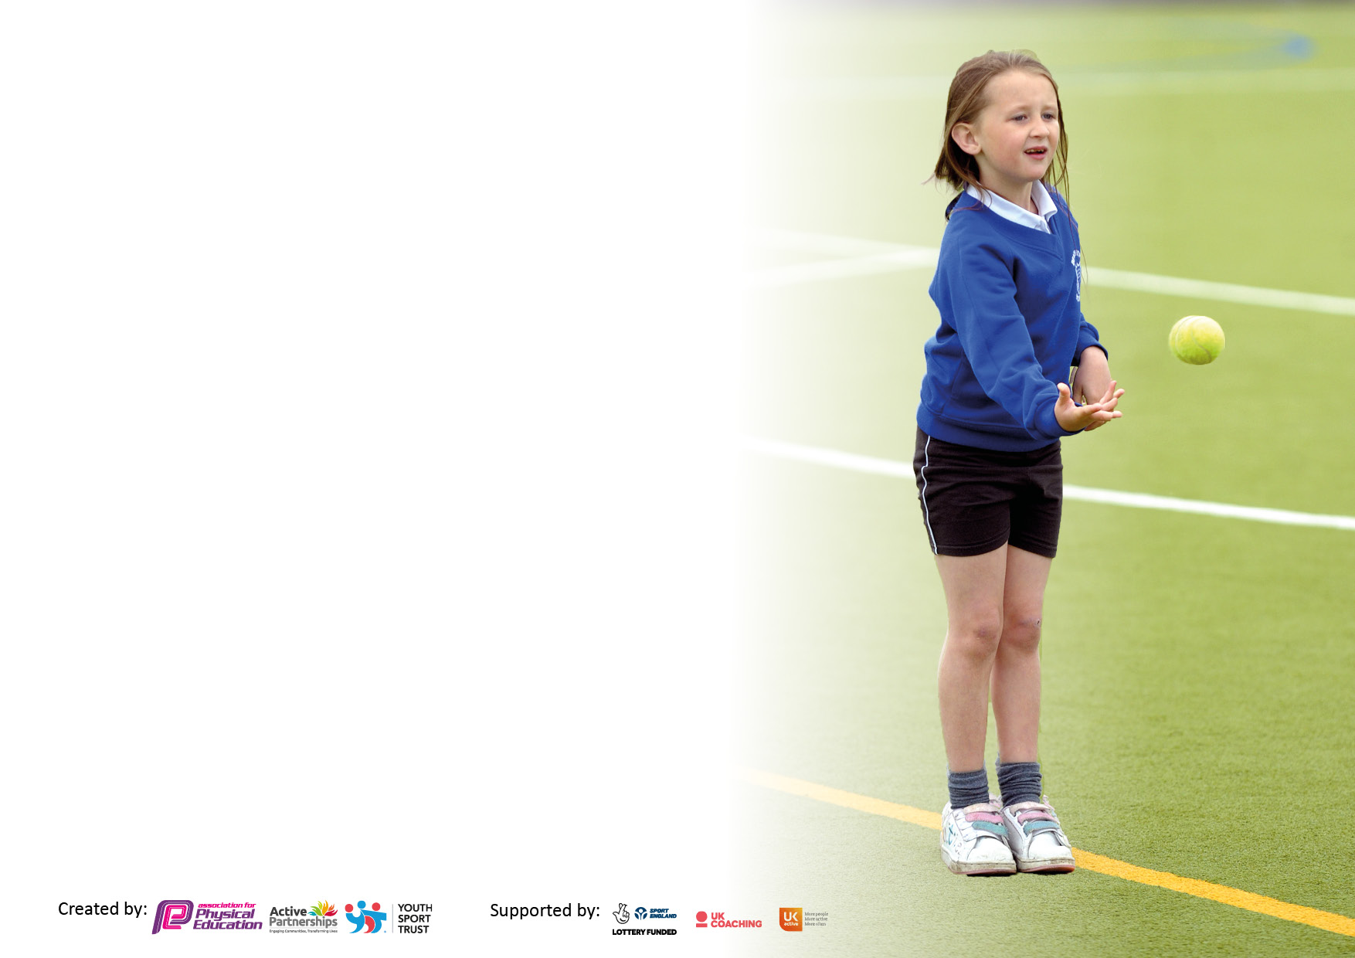

It is important that your grant is used effectively and based on school need. The Education Inspection Framework makes clear there will be a focus on ‘whether leaders and those responsible for governors all understand their respective roles and perform these in a way that enhances the effectiveness of the school’.

Under the Quality of Education Ofsted inspectors consider:
Intent - Curriculum design, coverage and appropriateness
Implementation - Curriculum delivery, Teaching (pedagogy) and Assessment
Impact - Attainment and progress

All funding must be spent by 31st July 2022.

We recommend regularly updating the table and publishing it on your website throughout the year. This evidences your ongoing self-evaluation of how you are using the funding to secure maximum, sustainable impact. Final copy must be posted on your website by the end of the academic year and no later than the 31st July 2021

Details with regard to funding
Please complete the table below.

Total amount carried over from 2019/20 | £5,864
Total amount allocated for 2020/21 | £16,750 (£22,614 with carry-over)
How much (if any) do you intend to carry over from this total fund into 2021/22? | £3,328
Total amount allocated for 2021/22 | £16,800
Total amount of funding for 2021/22. To be spent and reported on by 31st July 2022. | £20,128
Swimming Data
Please report on your Swimming Data below.

Meeting national curriculum requirements for swimming and water safety.  N.B. Complete this section to your best ability. For example you might have practised safe self-rescue techniques on dry land which you can then transfer to the pool when school swimming restarts.  Due to exceptional circumstances priority should be given to ensuring that pupils can perform safe self rescue even if they do not fully meet the first two requirements of the NC programme of study | Pupils do not start swimming lessons in NVA until Y4. Our current Y6 pupils have not been able to participate in swimming lessons at NVA due to the ongoing COVID restrictions.
What percentage of your current Year 6 cohort swim competently, confidently and proficiently over a distance of at least 25 metres?  N.B. Even though your pupils may swim in another year please report on their attainment on leaving primary school at the end of the summer term 2020.  Please see note above | % No data currently available.
What percentage of your current Year 6 cohort use a range of strokes effectively [for example, front crawl, backstroke and breaststroke]?  Please see note above | % No data currently available
What percentage of your current Year 6 cohort perform safe self-rescue in different water-based situations? | % No data currently available.
Schools can choose to use the Primary PE and sport premium to provide additional provision for swimming but this must be for activity over and above the national curriculum requirements. Have you used it in this way? | No

Action Plan and Budget Tracking
Capture your intended annual spend against the 5 key indicators. Clarify the success criteria and evidence of impact that you intend to measure to evaluate for pupils today and for the future.

Academic Year: 2020/21 | Total fund allocated: £20,128 | Date Updated: January 2022
Key indicator 1: The engagement of all pupils in regular physical activity – Chief Medical Officers guidelines recommend that primary school pupils undertake at least 30 minutes of physical activity a day in school |  |  |  | Percentage of total allocation:
 |  |  |  | 33%
Intent | Implementation |  | Impact
Focus | Actions | Funding allocated | Evidence | Sustainability and suggested next steps
Create more opportunities for children to sustain 30 minutes of physical activity every day. | Audit outdoors equipment and restock where needed.  Upgrade smooga (for playground demarcation to allow various activities to safely take place)  Purchase step counters for pupils to wear in school to encourage daily activity.  Join Steps to Summit Programme to engage and encourage pupils to be more active. Rewards and incentives for achievements.  Subscription to online activity Programme – Cybersmart (active classroom/wake and shake activities) | £500  £3,000  £2,400  £600  £180 | Pupils engaged in regular physical activity during break times and free time  Improved engagement in lessons and boosting physical health. | PE subject leader to ensure sporting/physical activity  opportunities are available and actively encouraged.  Varied activities/resources on offer at play times to encourage pupils to be active.  Daily exercise encouraged to improve physical health and well-being.
Key indicator 2: The profile of PESSPA being raised across the school as a tool for whole school improvement |  |  |  | Percentage of total allocation:
 |  |  |  | 25%
Intent | Implementation |  | Impact
Focus | Actions | Funding | Evidence | Sustainability and suggested next steps
Raise the profile of PE with parents and children, to encourage children to take part in school sports and parents to support them. | Share all sporting achievements in weekly assembly and on schools social media.  Playtime equipment used to encourage children to be more active  Race for Life event - sponsored run to raise money for Cancer Research. Event to be publicised on school social media.  School Fun Day with various sporting activities to raise money for local charity. Event to be shared on social media.  Daily Mile and Steps to Summit initiatives. Successes rewarded and shared with parents and on schools social media.  Pupils participate in competitions and festivals – inter and intra-school. | £4523  £500 | All participation and success has been shared with the rest of the school during assemblies.  Children are choosing to play sport at playtime.  Race for Life event and School Fun Day – updates of money raised and distance run to be recorded when completed.  Achievements recorded and rewarded. Pupils motivated to increase level of activity.  Pupils given the opportunity to attend festivals of sport to increase their enjoyment and opportunities. | Sports noticeboard in main entrance to include team photos and successes from competitions.  Continue to increase participation in festivals.  Pupils engaged in daily mile activity.  Pupils engage in Step to Summit programme.

Key indicator 3: Increased confidence, knowledge and skills of all staff in teaching PE and sport |  |  |  | Percentage of total allocation:
 |  |  |  | 8%
Intent | Implementation |  | Impact
Focus | Actions | Funding | Evidence | Sustainability and suggested
 |  |  |  | next steps
To raise the quality of teaching in PE and Sport – purchase of new PE teaching scheme: Get Set 4 PE  Develop knowledge, skills and confidence to teach the whole child through sport. | Roll out of new scheme shared with staff in Curriculum meetings. CPD offered via Get Set 4 PE – virtual tour of their site, including lesson plans and resources.  CPD in a range of activities also provided (online training) through our subscription. | £1650 | A sense of fun and enjoyment through sport and PE is engendered in all pupils.  PE subject lead to share resources / online support with staff - curriculum meetings.  Staff develop confidence in delivering high quality PE lessons.  Pupils will be engaged and develop skills. | PE scheme is in place moving forward, including progression ladders, curriculum mapping and a wide range of teaching and learning resources. This will help develop staffs PE knowledge, understanding and confidence in teaching PE. Scheme also provides regular CPD.  Further professional learning opportunities for staff who request it (eg. peer observations, buddying up, sharing of knowledge and skills).
Key indicator 4: Broader experience of a range of sports and activities offered to all pupils |  |  |  | Percentage of total allocation:
 |  |  |  | 34%
Intent | Implementation |  | Impact
Focus | Actions | Funding | Evidence | Sustainability and suggested next steps
To continue to enable pupils to experience a wide range of sports and activities.  To engage, motivate and enhance the learning of all pupils.  Offer extra-curricular sporting opportunities (Friday afternoons).  To encourage healthy lifestyles and offer pupils the opportunity to experience new activities in addition to those offered through the National Curriculum.  To ensure that staff and pupils have access to high quality PE equipment for use in lessons and during unstructured times.  To ensure specific equipment is available to meet the needs of all pupils (eg. sensory sporting equipment to be used for ASD pupils during PE and unstructured times) | Offer a range of workshops and activities beyond those offered through NC PE sessions: including Boccia, New Age Kurling, Yoga, indoor archery, hula-hooping  Continue engagement with and School Games and Panathlon initiatives.  Create links with local sports groups (eg. Foundation of Light).  Acquiring and upgrading appropriate school PE and sensory equipment | £1200  £575  £5,000 | Pupils will have access to a broader range of sporting activities and will have the opportunity to experience sports/activities that would not ordinarily be offered via the PE curriculum.  Pupils will be engaged and nurture an enjoyment of physical activity.  Pupils and staff will have access to a wider range of good quality PE and sensory equipment to develop skills and enhance teaching and learning experiences. | With equipment purchased to support these extra-curricular activities, pupils will be able to participate and develop their skills well into the future. Staff will be able to offer follow-up sessions to encourage further activity and development of skills.  With the improvement of the range and quality of our PE and sensory resources staff will be able to deliver engaging and well-resourced lessons and activities well into the future.
Key indicator 5: Increased participation in competitive sport |  |  |  | Percentage of total allocation:
 |  |  |  | 0%
Intent | Implementation |  | Impact
Focus | Actions | Funding | Evidence | Sustainability and suggested next steps
To participate in competitive sports, eg. Sportability, Sportshall Athletics, Panathlon and various city wide/regional sportsability festivals and competitions. | Maintain links with School Games officer.  Engage in competitions and festivals.  Engage in School Games and Sunderland Active Schools Charter programmes. | N/A | Pupils will have access to a broad range of sporting activities and will have the opportunity to participate in festivals and competitive sports.  Gold Standard Awards achieved in the Schools Games Award Scheme and the Sunderland Schools Active Charter. | Links with organisations and sporting groups carried forward and pupils encouraged to continue participation and engage in long-term physical actitivies.

Signed off by
Head Teacher:
Date:
Subject Leader:
Date:
Governor:
Date:

